Maesgwyn – Wind Farm Rules

Community Benefits
The Maesgwyn project has a £4.375m lifetime community benefit to be distributed at £175,000 per annum. The fund is secured by a Section 106. The monies are paid directly to and administered by NPT CBC with some input from PW. The benefit is available for qualifying projects in the communities of Banwen, Onllwyn and Glynneath. Monies not spent in any year are rolled up within the company and ring fenced for future spend. All applications are made directly to NPT CBC.

A very large number of projects have been supported to date and these are collated in the appended table (DH to check)

Some examples are given below for Onllwyn only from NPT CBC tabular record.

Ref. No | Organisation | Project Activity | Amount Requested
001 | Banwen & District Pony Club 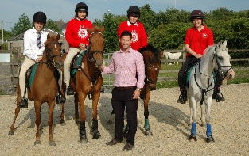 | Ménage | £19,700
009 | Banwen RFC | Pitch drainage scheme | £18,850
016 | Onllwyn Community Council | Skate Park | £26,850.00
023 | Age Connect NPT | Outreach Development Worker | £14,578.49
024 | Onllwyn Community Council | Refurbishment of Pantyffordd Play Area | £28,211.00
027 | Onllwyn Community Council | Conversion of tennis courts into a MUGA | £25,523.40
029 | Banwen RFC | Convert ATP to a 3G | £29,655.56
042 | Age Connects NPT | Counselling, welfare and health advice through Outreach Officers | £29,658.67 (over 2 years)
048 | DOVE Workshop | Media hub | £21,924.14
049 | Banwen RFC | Funding to purchase new tractor and equipment | £14,810.00
050 | Onllwyn Community Council | Working with Nature project - development of the wooded area near the pond and DOVE area | £11,288.32

