Pant y Wal Community Fund Rules

The PyW project has a £1.5m lifetime community benefit to be distributed at £60,000 per annum. The fund was not secured by a Section 106 (one was not sought by the LPA) and is paid voluntarily by the company.

Project Location
The benefit is available for qualifying projects in the communities that lie within Bridgend CBC nearest to this windfarm i.e. Evanstown and Glynogwr.

Note: The adjacent Fforch Nest windfarm has a matching fund for neighbouring communities in RCT CBC). Monies not spent in any year are rolled up within the company and ring fenced for future spend.

When to Apply
The wind farm operational year closes in May of each year after which the fund is distributed to successful applicants following the approval of the Board Paper (usually in June) detailing the applicants for the year. Applications to the fund can be made in any month up to April of the relevant operational year.

How to Apply
Individuals or groups can apply directly or via a councillor or community councillor either by phone, letter or email. Typical projects are usually community development, sports or youth development of various kinds (we provide some examples below).

Example Projects
Some examples of the type of projects the Fund will support are given below:
- Projects to improve public amenities e.g. community halls, sports facilities (with Bridgend CBC we have supported schemes at Gilfach Goch RFC sports ground, Evanstown community centre and Abercerdin Primary School)
- Footpath works
- Environmental and wildlife projects including projects to improve public parks and open spaces
- Activities / events to engage the local community
- Energy efficiency or renewable energy projects, such as insulation, efficient boilers or small scale renewable energy installations at community amenities.

The above list is not exhaustive and is provided to give ideas only.

Eligible Organisations:
Eligible Organisations, who can apply for funding include:
- Voluntary and community groups
- Parish and Town Councils
- Local Authorities (if they are applying on behalf of a community organisation and they are delivering a project that has come directly from the community)
Note – evidence that projects are community driven may be required
- Charities (delivering local services)
- Schools and educational establishments (delivering projects outside the LEA requirements)
- Social enterprises (including credit unions, co-operatives, social firms, community owned enterprises, community interest companies and development trusts) provided they operate on a not-for-profit basis.

Applicants need to have a written constitution, a set of rules, or a governing document and a bank or building society account held in the name of the organisation in place before applying for a grant.

Exclusions
Grants will not be available for:
- Commercial organisations.
- Private membership-based sports clubs and facilities unless membership is open to the general public without undue restriction (e.g. not membership by nomination organisations or with restrictive charges).
- Projects that only benefit one individual.
- Projects that are narrowly religious in focus or that support a party political campaign.
- Retrospective funding, i.e. projects that have already been completed, whether or not already paid for.
- Works considered a statutory responsibility, such as scheduled transport services, works to public highways and public car parks.

Judging Criteria
The main criteria used when assessing applications received will be:
- The social, economic and environmental benefits which will result from the project.
- The level of community support for and involvement in the project.
- Other factors will also be considered which must be demonstrated in the application:
- The ability of the applicant to deliver the project.
- How the work will be continued after the project has been completed i.e. its sustainability and legacy.
- Value for money.
- For applications above £2,000, does the application demonstrate any contribution towards the project by the applicant organisation, for example match funding or a gift in-kind of labour and / or materials.

If, after reading the above, you are confident that your project meets the criteria, please get in touch.

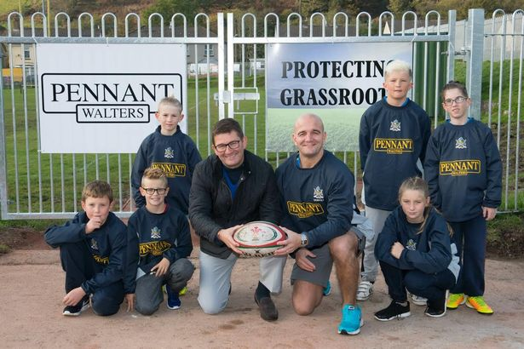

https://www.walesonline.co.uk/news/wales-news/rugby-club-given-45k-build-12095074

https://www.walesonline.co.uk/news/local-news/pitch-animals-wont-stopping-play-10219295

Additional information:
Extract from letter from Helen Gentle the headmistress at Abercerdin School, Evanstown.
“The school continues to be graded as a Green 1 A on Welsh Government categorisation. I was recently singing your praises to the MP Chris Elmore (he visited before Easter). I’d explained to him that the children and community had lacked an enormous amount of community facilities and opportunities as we are a satellite area of Bridgend. The opportunities have purely come from the funding that you have provided. This has ensured that the children have the same educational opportunities as the rest of Bridgend. The school is therefore able to perform at the highest levels due to Pennant Walters’ regeneration of its community facilities. You have changed and still are supporting a once failing and underachieving school allowing it to become one of the best in Wales. The impact of the Pennant Walters’ funding on the school and this community is immense and has turned lives around. It’s also given a great deal of confidence to the community knowing that somebody cares and will support the community.”

